

Stage Plan
(3 monitors, 2 DIs, 5 Mics, 5 Stands and 3 chairs as below)

chair chair chair
(Depends on venue) (Always seated) (Depends on venue)
Fiachra Shane Aodán
(Fiddle, Vox 1) (Accordion L&R, Vox 2) (Guitar, Vox3)

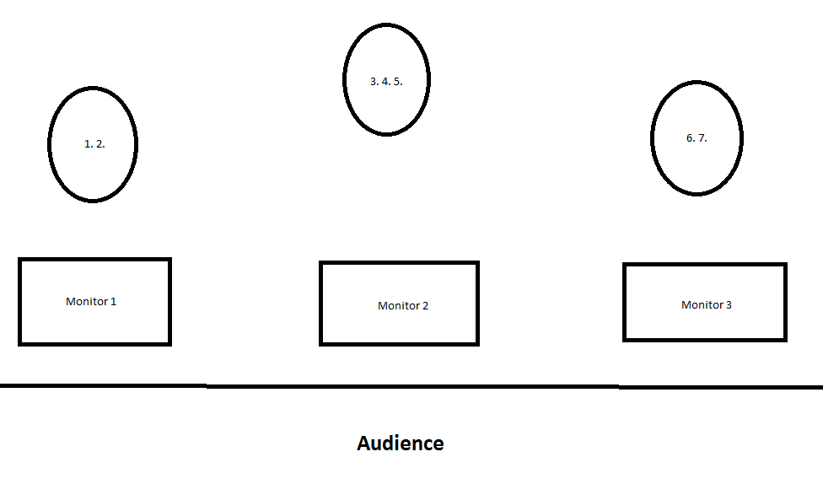
Channel Information

1. Fiddle DI box
2. Backing vocals Mic (Vox1) SM58, Tall Boom
3. Accordion Shure SM57, Short Boom, melody (Right hand)
4. Accordion Shure SM57, Short Boom, bass (Left hand)
5. Backing vocals Mic (Vox2) Shure SM58, Tall Boom
6. Guitar DI box
7. Main Vocals Mic (Vox3) Shure SM58, Tall Boom

Technical Rider
Note: All sound equipment, including microphones, to be provided by venue.
3 seats without arms to be provided on stage.

PA requirements

Front of House
A professional quality stereo 4 way active system. Minimum 4kW for 20Hz - 20KHz. Capable of producing 115dB of undistorted sound at the mix position. Channels should have two swept mid controls plus high and low frequency controls, phase, high pass filter and phantom power plus min100mm faders. If at all possible, desk to be located on same level as audience and in centre position, not under a balcony or in a control room.

-2 dedicated digital stereo reverb units
-1 dedicated digital delay unit with tapper
-6 compressors

Monitors
Three separate mixes please with good quality monitors, free from hums and buzzes and with 31 band graphic EQs.

Staging
If stage is low and there is a chance of visibility problems, please supply risers for all members. As the musicians are seated, a low stage in a standing venue, for example, means that only the first row of audience can see them.

Lighting

We do not travel with a lighting engineer but really appreciate an LD who is prepared to be creative.

The music is very dynamic ranging from quiet and slow to loud and fast and as such we like lighting to be quite dramatic to reflect the mood. We like floor cans, lighting from behind, haze, and anything unusual. We don’t require spots for solos but it’s good if the audience can see the face of whoever’s singing (centre stage) or talking (all 3).

If you have any queries regarding sound, please contact Aodán on +353868982842
Or e-mail: socksinthefryingpan@gmail.com

